**LOOPS, Conditional Statements and Nested Loops**

1. Create a pattern

12345678

1234567

123456

12345

1234

123

12

1

1. Make a program to count the total number of digits in a number.
2. Make a program to display Fibonacci series up to 10 terms.
3. Make a program to Reverse a given integer number

Given:

1897

Expected output:

7981

1. Program to generate Pythagorean numbers
2. Write a Python program that accepts a word from the user and reverse it
3. Write a program to print the following pattern

A

B C

D E F

G H I J

K L M N O

1. Create the pattern

1

1 2

1 2 3

1 2 3 4

1 2 3 4 5

1 2 3 4

1 2 3

1 2

1

1. Print the pattern

If n=10

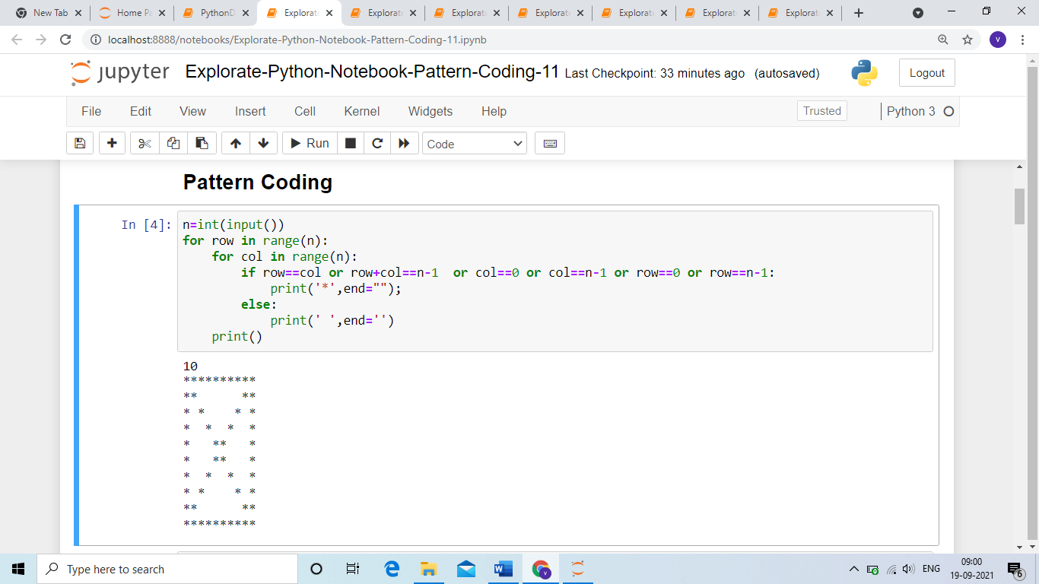

If n=6

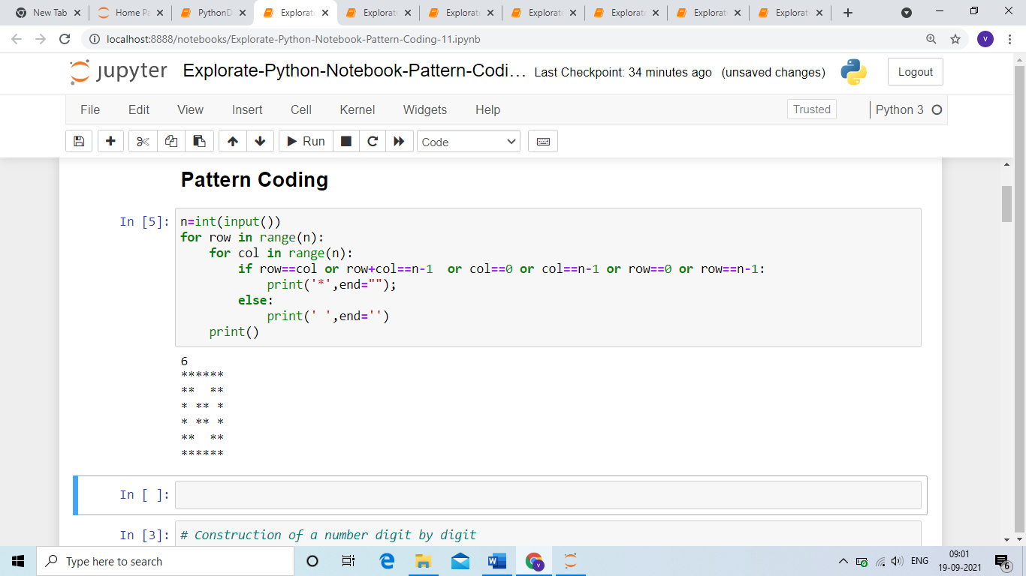

1. Write a Python program to count the number of even and odd numbers from a series of numbers.

Sample numbers:

numbers = (4, 12,23, 94, 25, 36, 47, 18, 19)

Expected Output :

Number of even numbers: 5

Number of odd numbers: 4

1. Write a Python program which iterates the integers from 1 to 50. For multiples of three print "BE" instead of the number and for the multiples of five print "CSE". For numbers which are multiples of both three and five print "BECSE".

Sample Output :

1

2

BE

4

CSE

BE

7

8

BE

CSE

11

BE

13

14

BECSE

1. Write a Python program that accepts a string and calculate the number of digits and letters.
2. Write a Python program to print alphabet pattern 'E'

*****

*

*

****

*

*

*****